**Plant Genes Lab Workbook**

**Kids’ Tech University**

**January 24, 2015**

**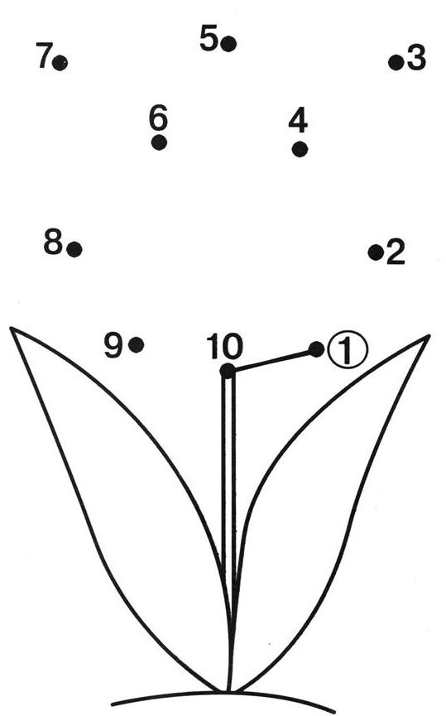**

My name is \_\_\_\_\_\_\_\_\_\_\_\_\_\_\_\_\_\_\_\_\_\_\_\_\_\_\_\_\_\_\_\_\_\_\_\_\_\_\_\_\_\_\_\_\_\_\_\_\_\_\_\_\_\_

My volunteer’s name is \_\_\_\_\_\_\_\_\_\_\_\_\_\_\_\_\_\_\_\_\_\_\_\_\_\_\_\_\_\_\_\_\_\_\_\_\_\_\_\_\_\_\_\_

My neighbor’s name is \_\_\_\_\_\_\_\_\_\_\_\_\_\_\_\_\_\_\_\_\_\_\_\_\_\_\_\_\_\_\_\_\_\_\_\_\_\_\_\_\_\_\_\_\_

**Lab 1: Connect the dots**

**Open the Plant Gene Lab file on the desktop**

**Plant Genes**

* Plant genes contain the information that gives the plant its physical and functional properties.
* These properties could be if the plant is a tree or a flower, if it is tall or short, if it grows in the shade or sun, if it grows fruits or vegetables, if it gets a disease or not, and many others.
* Plant genes interact with each other in many different ways to create gene networks.

**Vertex-Edge Graphs**

* This lab introduces you to the foundational mathematics that plant biologists use to model plant gene networks.

**Lab 1: Connect the dots**

**Graph Theory**

* Mathematicians developed \_\_\_\_\_\_\_\_\_\_\_\_\_\_\_\_\_ \_\_\_\_\_\_\_\_\_\_\_\_\_\_\_\_\_

to study all kinds of networks.

* A \_\_\_\_\_\_\_\_\_\_\_\_\_\_\_\_\_ is a set of dots connected by lines.

**Vertex-Edge Graph**

* The dot in a graph is usually called a \_\_\_\_\_\_\_\_\_\_\_\_\_\_\_\_\_ or \_\_\_\_\_\_\_\_\_\_\_\_\_\_\_\_\_.
* The line connecting two dots in a graph is called an \_\_\_\_\_\_\_\_\_\_\_\_\_\_\_\_\_.

**Example**

* In this \_\_\_\_\_\_\_\_\_\_\_\_\_\_\_\_\_ there is one \_\_\_\_\_\_\_\_\_\_\_\_\_\_\_\_\_ that connects two \_\_\_\_\_\_\_\_\_\_\_\_\_\_\_\_\_.
* We write the vertices as a list \_\_\_\_\_\_\_\_\_\_\_\_\_\_\_\_\_ and the edges as a list of pairs of vertices \_\_\_\_\_\_\_\_\_\_\_\_\_\_\_\_\_.

**Lab 1: Connect the dots**

**Example**

* In this \_\_\_\_\_\_\_\_\_\_\_\_\_\_\_\_\_ there are three \_\_\_\_\_\_\_\_\_\_\_\_\_\_\_\_\_ and four \_\_\_\_\_\_\_\_\_\_\_\_\_\_\_\_\_.
* We write the vertices as a list \_\_\_\_\_\_\_\_\_\_\_\_\_\_\_\_\_ and the edges as a list of pairs of vertices \_\_\_\_\_\_\_\_\_\_\_\_\_\_\_\_\_.

**Undirected Edge**

* Look at the list of pairs E={{1,2}, {1,3}, {3,4}}.
* An \_\_\_\_\_\_\_\_\_\_\_\_\_\_\_\_\_ \_\_\_\_\_\_\_\_\_\_\_\_\_\_\_\_\_ from vertex 1 to vertex 2 \_\_\_\_\_\_\_\_\_\_\_\_\_\_\_\_\_ is *the* \_\_\_\_\_\_\_\_\_\_\_\_\_\_\_\_\_ *thing* as an undirected edge from vertex 2 to vertex 1 \_\_\_\_\_\_\_\_\_\_\_\_\_\_\_\_\_.

**Lab 1: Connect the dots**

**Undirected graph**

|  |  |
| --- | --- |
| * List the vertices * List the edge * Draw the following edges   E={{1,2}, {2,3}, {3,4}, {4,10}, {5,10}, {5,6}, {6,10}, {7,10}, {7,8}, {8,9}, {9,10}} | **connect_the_dots_printable_dot___coloring_pages_for_adults_coloring_pages_for_teenagers.jpg** |

**Loop**

* An edge with identical vertices is a \_\_\_\_\_\_\_\_\_\_\_\_\_\_\_\_\_.
* V=\_\_\_\_\_\_\_\_\_\_\_\_\_\_\_\_\_ and E=\_\_\_\_\_\_\_\_\_\_\_\_\_\_\_\_\_.

**Lab 1: Connect the dots**

**Example**

|  |  |
| --- | --- |
| * Add the following loops   E={{3,3}, {4,4}, {8,8}} | **connect_the_dots_printable_dot___coloring_pages_for_adults_coloring_pages_for_teenagers.jpg** |

**Practice**

|  |  |
| --- | --- |
| * Complete the following graph. * E={{1,2}, {2,3}, {3,4}, {4,10}, {10,5}, {5,5}, {10,6}, {6,7}, {7,8}, {8,9}, {9,10}} | **connect_the_dots_printable_dot___coloring_pages_for_adults_coloring_pages_for_teenagers.jpg** |

**Lab 1: Connect the dots**

**Your Graph**

|  |  |
| --- | --- |
| * Draw your own graph. * List the edges. * Write your list of edges on an index card and give it to your neighbor. | **connect_the_dots_printable_dot___coloring_pages_for_adults_coloring_pages_for_teenagers.jpg** |

**Neighbor’s Graph**

|  |  |
| --- | --- |
| * Use your neighbor’s list of edges to draw your neighbor’s graph. * Compare your graph and your neighbor’s graph. * Did you draw the same graph as your neighbor? | **connect_the_dots_printable_dot___coloring_pages_for_adults_coloring_pages_for_teenagers.jpg** |

**Lab 1: Connect the dots**

**Subgraph**

* Part of a graph is called a \_\_\_\_\_\_\_\_\_\_\_\_\_\_\_\_\_.
* V=\_\_\_\_\_\_\_\_\_\_\_\_\_\_\_\_\_and E=\_\_\_\_\_\_\_\_\_\_\_\_\_\_\_\_\_.

**Example**

|  |  |
| --- | --- |
| * Highlight the subgraph. * E={{10,7}, {7,8}, {8,9}, {9,10}} | **connect_the_dots_printable_dot___coloring_pages_for_adults_coloring_pages_for_teenagers.jpg** |

**Lab 1: Connect the dots**

**Adjacent Vertices**

* Two vertices are called \_\_\_\_\_\_\_\_\_\_\_\_\_\_\_\_\_ if they share a common edge.
* Vertices \_\_\_\_\_\_\_\_\_\_\_\_\_\_\_\_\_ are \_\_\_\_\_\_\_\_\_\_\_\_\_\_\_\_\_.
* Vertices \_\_\_\_\_\_\_\_\_\_\_\_\_\_\_\_\_ are \_\_\_\_\_ \_\_\_\_\_\_\_\_\_\_\_\_\_\_\_\_\_.

**Example**

|  |  |
| --- | --- |
| * What vertices are adjacent to vertex 7? * What vertex is not adjacent to vertex 7? | **connect_the_dots_printable_dot___coloring_pages_for_adults_coloring_pages_for_teenagers.jpg** |

**Lab 1: Connect the dots**

|  |  |  |  |  |  |  |  |  |  |  |  |  |  |  |  |  |  |  |  |  |  |  |  |  |  |  |
| --- | --- | --- | --- | --- | --- | --- | --- | --- | --- | --- | --- | --- | --- | --- | --- | --- | --- | --- | --- | --- | --- | --- | --- | --- | --- | --- |
| |  |  |  |  |  | | --- | --- | --- | --- | --- | | **V** | **1** | **2** | **3** | **4** | | **1** | **0** | **1** | **1** | **0** | | **2** | **1** | **0** | **0** | **1** | | **3** | **1** | **0** | **0** | **1** | | **4** | **0** | **0** | **1** | **0** | |  |

**Adjacency Matrix**

* An \_\_\_\_\_\_\_\_\_\_\_\_\_\_\_\_\_ \_\_\_\_\_\_\_\_\_\_\_\_\_\_\_\_\_ is a way of showing which vertices of a graph are adjacent.
* We write a \_\_\_ if vertices are \_\_\_\_\_\_\_\_\_\_\_\_\_\_\_\_\_.
* We write a \_\_\_ if vertices are \_\_\_\_\_\_\_\_\_\_\_\_\_\_\_\_\_.

**Example**

|  |  |  |  |  |  |  |  |  |  |  |  |  |  |  |  |  |  |  |  |  |  |  |  |  |  |  |
| --- | --- | --- | --- | --- | --- | --- | --- | --- | --- | --- | --- | --- | --- | --- | --- | --- | --- | --- | --- | --- | --- | --- | --- | --- | --- | --- |
| * Fill in the adjacency matrix  |  |  |  |  |  | | --- | --- | --- | --- | --- | | **V** | **7** | **8** | **9** | **10** | | **7** |  |  |  |  | | **8** |  |  |  |  | | **9** |  |  |  |  | | **10** |  |  |  |  | | **connect_the_dots_printable_dot___coloring_pages_for_adults_coloring_pages_for_teenagers.jpg** |

**Lab 2: Gene Networks**

**Go to the NCTM Graph Creator website:**

<http://illuminations.nctm.org/Activity.aspx?id=3550>

**Plant Genes**

* Plant genes contain the information that gives the plant its physical and functional properties.
* These properties could be if the plant is a tree or a flower, if it is tall or short, if it grows in the shade or sun, if it grows fruits or vegetables, if it gets a disease or not, and many others.
* Plant genes interact with each other in many different ways to create gene networks.

**Plant Gene Network**

* This lab introduces you to paths, circuits, and feedback loops, which are the building blocks for plant gene networks.
* Vertices (dots) will represent the genes.
* Edges (lines) will represent their interactions.

**Lab 2: Gene Networks**

**Follow the directions.**

**Place a ✓ in the ☐ as you complete each task.**

**Use the vertex tools**

* Use ADD VERTEX Macintosh HD:Users:hollytimme:Desktop:add-vertex.jpg to create A, B, C, D, and E on your workspace.
* Use SELECT VERTEX Macintosh HD:Users:hollytimme:Desktop:select-vertex.jpg to select vertex A.
* Use COLOR PALETTE Macintosh HD:Users:hollytimme:Desktop:color-palette.jpg to change vertex A from black to red.
* Change the colors: B to blue, C to green, D to yellow, and E to purple.
* Use SELECT VERTEX Macintosh HD:Users:hollytimme:Desktop:select-vertex.jpg to select vertex A.
* Type W above “label” and click ok.
* Change the labels: B to X, C to Y, D to Z, and E to V.
* Use SELECT VERTEX Macintosh HD:Users:hollytimme:Desktop:select-vertex.jpg to select vertex V.
* Use DELETE SELECTED Macintosh HD:Users:hollytimme:Desktop:delete-selected.jpg to delete vertex V.
* Use ADD VERTEX Macintosh HD:Users:hollytimme:Desktop:add-vertex.jpg to create vertex A on your workspace.
* Use SELECT VERTEX Macintosh HD:Users:hollytimme:Desktop:select-vertex.jpg to select vertex A.
* Place **✓** in the **☐** above “show degree.”

What is the degree of vertex A? \_\_\_\_\_\_\_\_\_\_\_\_\_\_\_\_\_

**Lab 2: Gene Networks**

**Use the edge tools**

* Use ADD EDGE Macintosh HD:Users:hollytimme:Desktop:add-edge.jpg to add an edge between A and W.
* Add the edges: A to X and A to Y.
* Use ADD DIRECTED EDGE Macintosh HD:Users:hollytimme:Desktop:add-directed-edge.jpg to add a directed edge between A and Z.
* Use BEND EDGE Macintosh HD:Users:hollytimme:Desktop:bend-edge.jpg to bend the edge between A and W.
* Use SELECT EDGE Macintosh HD:Users:hollytimme:Desktop:select-edge.jpg to select the edge between A and Y.
* Use COLOR PALETTE Macintosh HD:Users:hollytimme:Desktop:color-palette.jpg to change that edge from black to pink.
* Use SELECT EDGE Macintosh HD:Users:hollytimme:Desktop:select-edge.jpg to select the edge between A and X.
* Use DELETE SELECTED Macintosh HD:Users:hollytimme:Desktop:delete-selected.jpg to delete the edge between A and X.

Now, what is the degree of vertex A? \_\_\_\_\_\_\_\_\_\_\_\_\_\_\_\_\_

* **The DEGREE OF A VERTEX is the number of edges that touch the vertex.**
* Use COMPLETE GRAPH Macintosh HD:Users:hollytimme:Desktop:complete-graph.jpg, then click “ok.”
* **A COMPLETE GRAPH is an undirected graph in which each pair of vertices is connected by one edge.**

Now, what is the degree of vertex A? \_\_\_\_\_\_\_\_\_\_\_\_\_\_\_\_\_

What is the degree of vertices X, W, Y, and Z? \_\_\_\_\_\_\_\_\_\_\_\_\_\_\_\_\_

**Lab 2: Gene Networks**

**Use the graph explorer tools**

* Use the HIGHLIGHTER Macintosh HD:Users:hollytimme:Desktop:highlighter.jpg to highlight vertex A.
* Highlight: vertex W and the edge between A and W.
* **Two vertices are ADJACENT if they share an edge.**

Name a vertex adjacent to both A and W: \_\_\_\_\_\_\_\_\_\_\_\_\_\_\_\_\_

* Use the HIGHLIGHTER Macintosh HD:Users:hollytimme:Desktop:highlighter.jpg to highlight vertex A.
* Highlight: vertex W and the edge between A and W.
* Highlight: vertex X and the edge between W and X.
* Highlight: vertex Z and the edge between X and Z.
* **A PATH is an ordered list of vertices such that there is an edge connecting adjacent vertices and each vertex is listed only once.**

**A path can start and end at different vertices.**

List the vertices in the highlighted path from A to Z: \_\_\_\_\_\_\_\_\_\_\_\_\_\_\_\_\_

List the vertices in the highlighted path from Z to A: \_\_\_\_\_\_\_\_\_\_\_\_\_\_\_\_\_

* Highlight: vertex Y and the edge between Z and Y.
* **A HAMILTONIAN PATH is a path where each *vertex* is used only once.**

**Lab 2: Gene Networks**

* Highlight: vertex Z and the edge between A and Z.
* **A CIRCUIT is a path that starts and ends at the same vertex.**
* Complete the following circuit: (A, Z, Y, X, W, A)

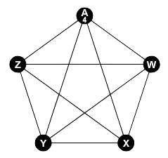

Did you trace every edge in the graph? \_\_\_\_\_\_\_\_\_\_\_\_\_\_\_\_\_

* **An EULER PATH is a path where each *edge* is used exactly once.**

Complete the following path: (A, Z, Y, X, W, A, Y, W, Z, X, A)



**Lab 2: Gene Networks**

Can you draw an Euler path for each graph? Write the order of the vertices.

(Hint: Draw the shape without lifting your pencil and without retracing any line)

**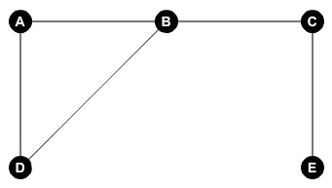** \_\_\_\_\_\_\_\_\_\_\_\_\_\_\_\_\_\_\_\_\_\_\_\_\_\_\_\_\_\_\_\_

**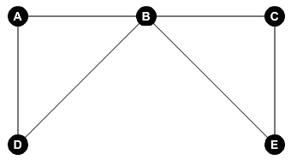**\_\_\_\_\_\_\_\_\_\_\_\_\_\_\_\_\_\_\_\_\_\_\_\_\_\_\_\_\_\_\_\_

**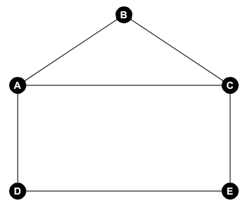**\_\_\_\_\_\_\_\_\_\_\_\_\_\_\_\_\_\_\_\_\_\_\_\_\_\_\_\_\_\_\_\_

**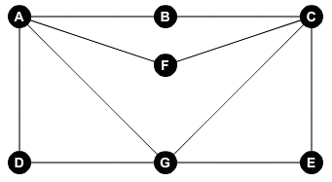**\_\_\_\_\_\_\_\_\_\_\_\_\_\_\_\_\_\_\_\_\_\_\_\_\_\_\_\_\_\_\_\_

**Lab 2: Gene Networks**

* Use CLEAR ALL Macintosh HD:Users:hollytimme:Desktop:Screen Shot 2015-01-14 at 9.06.15 PM.png to delete the last graph.
* Draw the following graph using the vertex and edge tools:

****

Consider the following Euler path: (B, A, D, B, C, E)

* Use SELECT EDGE Macintosh HD:Users:hollytimme:Desktop:select-edge.jpg to select the edge between vertex A and vertex B.
* Place **✓** in the **☐** above “directed.”
* Click <> above “direction” so the arrow points from vertex B to vertex A.
* Put directions on each of the edges to complete the directed graph:

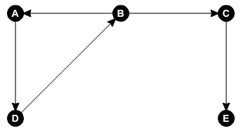

* **A DIRECTED GRAPH or DIRECTED NETWORK is a graph where all the edges are directed from one vertex to another.**

Write the path from vertex A to vertex E: \_\_\_\_\_\_\_\_\_\_\_\_\_\_\_\_\_

Which edge is missing? \_\_\_\_\_\_\_\_\_\_\_\_\_\_\_\_\_

Is there a path from vertex E to vertex A? \_\_\_\_\_\_\_\_\_\_\_\_\_\_\_\_\_

**Lab 3: Plant Sim Lab**

**Go to the Plant Sim Lab website:**

<http://ktu.plantsimlab.org/home.php>

**About Plant Sim Lab**

* Plant Sim Lab is a simulation laboratory for plant biologists.
* Plant biologists like Dr. McDowell can use it to model plant gene networks.
* We can use this sophisticated program to model the plant gene network for flowering plant called Arabidopsis.

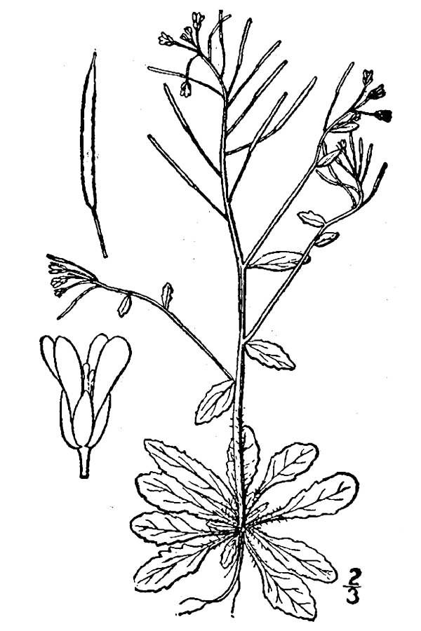

plants.usda.gov

**Lab 3: Plant Sim Lab**

**Follow the directions.**

**Place a ✓ in the ☐ as you complete each task.**

**Sign Up**

* Choose “Sign Up” to sign up for an account.
* Create your Username.
* Use the email address “ [YourLastName@ktu.edu](mailto:YourLastName@ktu.edu)”

(or you can make up your own email address)

* Create your Password.
* Click “Sign Up.”

**Log In**

* Type in your Username.
* Type in your Password.
* Click “Log In.”

**Facts about *Arabidopsis thaliana* (source:** [**http://nih.gov**](http://nih.gov)**)**

* *Arabidopsis thaliana* is a small flowering plant that is widely used as a model organism in plant biology.
* Arabidopsis is a member of the mustard family, which includes cabbage.
* Seed production is prolific and the plant is easily cultivated.
* Extensive genetic and physical maps are available.

**Lab 3: Plant Sim Lab**

**Model the gene network for flower development in *Arabidopsis thaliana***

**(source:** [**http://biologie.ens-lyon.fr**](http://biologie.ens-lyon.fr)**)**

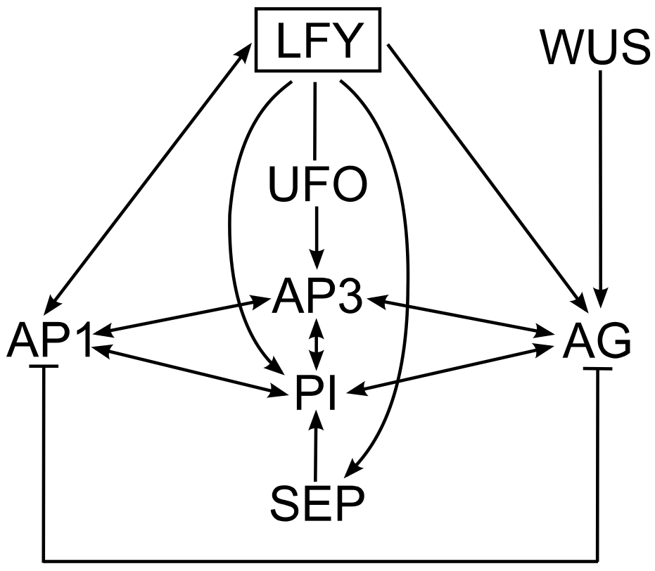

* Use ADD NODE to create a node in your workspace.
* Type the Short Name: LFY
* Choose Number of States: 2
* Choose Color: Black
* Choose Shape: Square
* Click “Submit.”
* Choose “Pre-defined names.”
* Click “Submit.”
* Use ADD NODE to create a node in your workspace.
* Type the Short Name: AP1
* Choose Number of States: 2
* Choose Color: Gray
* Choose Shape: Circle
* Click “Submit.”
* Choose “Pre-defined names.”
* Choose low/high.
* Click “Submit.”
* Use ADD ACTIVATING EDGE to create an edge from LFY to AP1.
* Leave the Edge Name Unnamed
* Click “Default.”
* Use ADD NODE to create a node in your workspace.
* Type the Short Name: AG
* Choose Number of States: 2
* Choose Color: Gray
* Choose Shape: Circle
* Click “Submit.”
* Choose “Pre-defined names.”
* Choose low/high.
* Click “Submit.”
* Use ADD INHIBITING EDGE to create an edge from AP1 to AG.
* Leave the Edge Name Unnamed
* Click “Default.”
* Continue to add nodes and edges until you have modeled the gene network for flower development in *Arabidopsis thaliana.*



* As your model gets bigger, click ZOOM OUT so you can see all the nodes.
* Click SCREEN CAPTURE to take a picture of your model.
* Click “Leave Page.”
* Compare your model with your neighbor.